MEMBERSHIP APPLICATION
OHIO STATE NEW ZEALAND RABBIT BREEDERS ASSOCIATION
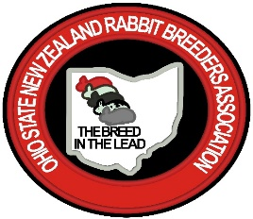
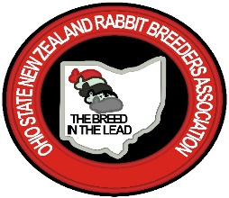
Dues:
Single - $8 yearly
Married Couple - $10 yearly
Family - $12 yearly
Newsletter (check one)
___ by email, no charge
___ by US mail, include additional $10 yearly

Make checks payable to: OSNZRBA
Name | Adult/Youth | Youth Date of Birth | ARBA #

Amount Paid: ______________________ Date: ________________________ Cash/Check#_________
Contact Information:
First Name ____________________________________ Last Name ________________________________
Address: ____________________________________________________________________________
____________________________________________________________________________
Phone Number: _______________________________________________
Email: __________________________________________________________________________________
Mail Form and Dues to: Amanda Hutcheson Questions: osnzrba@gmail.com or (419)733-9997
278 Poplar Street
Pataskala, Oh. 43062

---------------------------------------------------------------------------------------------------------------------------------------------------

Dues Receipt

First Name ___________________________________ Last Name _______________________________

Amount Paid: __________________________ Date: ______________________________

Club Secretary Signature: ________________________________________________________________

